MACH4METAL

metalworking machinery
Transito 21
6909 DA BABBERICH Netherlands
Tel. +31 (0)316-247123
Fax: +31 (0)316-247956
info@mach4metal.com
www.mach4metal.com

Bank No : 66.52.13.883
IBAN : NL33 INGB 0665 2138 83
BIC : INGBNL2A

RAS CNC Folding machine 4.5 mm

- Merk : RAS Germany
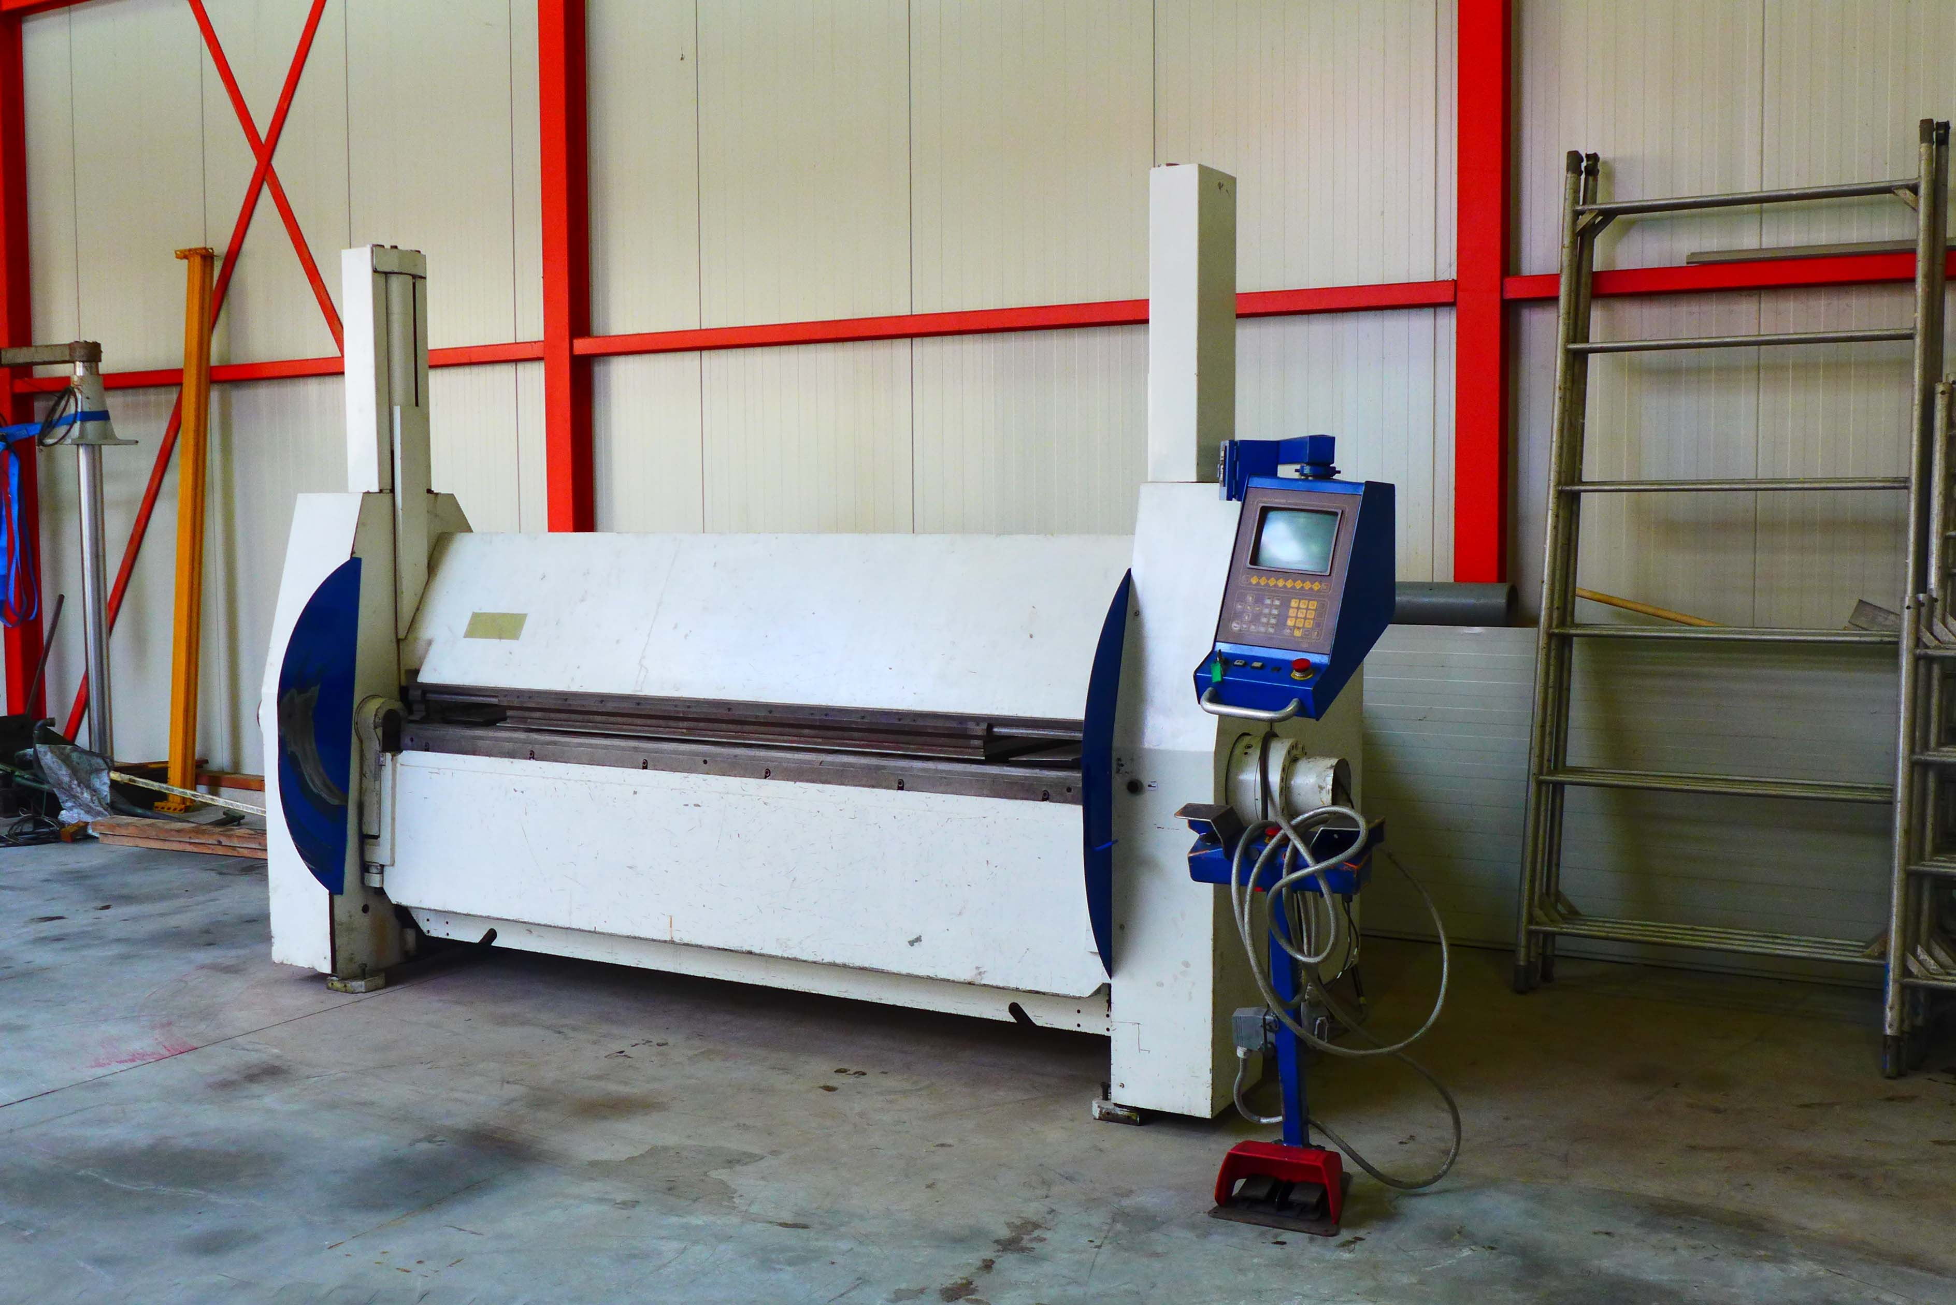
- Type : 74 . 25
- Mach.No : 230072
- Bouwjaar : 03 . 19887

- Folding length : 2.540
- Plate thickness : 4.5 mm

- Min. bending radius : 1.25 x thickness

- Stroke upper beam : 400
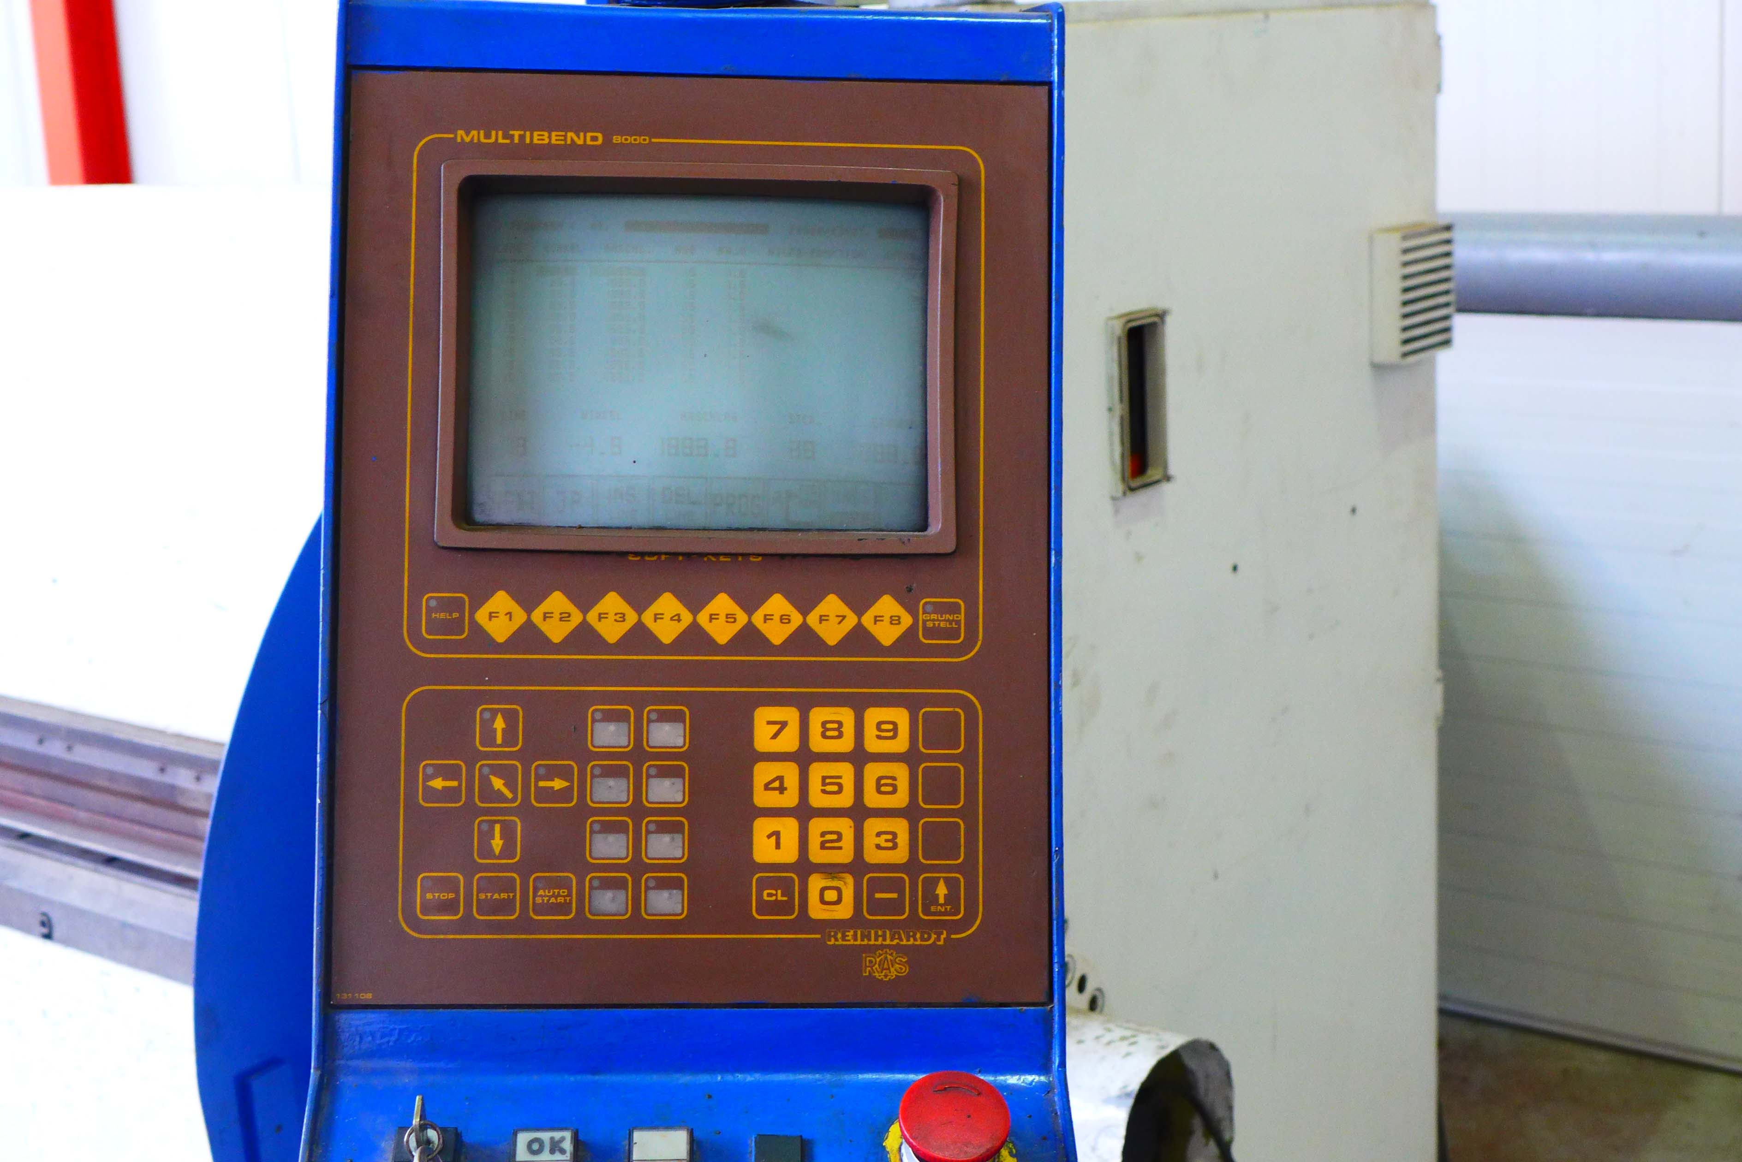
- Adj. Vertical bend beam : 80
- Bending angle : 180 Gr.

- Bending speed : 70 Gr / Sec.
- Stroke upper beam up : 44 mm/Sec
- Stroke upper beam down : 90 mm/Sec.
- Power : 7.5 kW

- MULTIBEND 8000 Backagauge control
Back gauge depth 10 - 1.500 mm
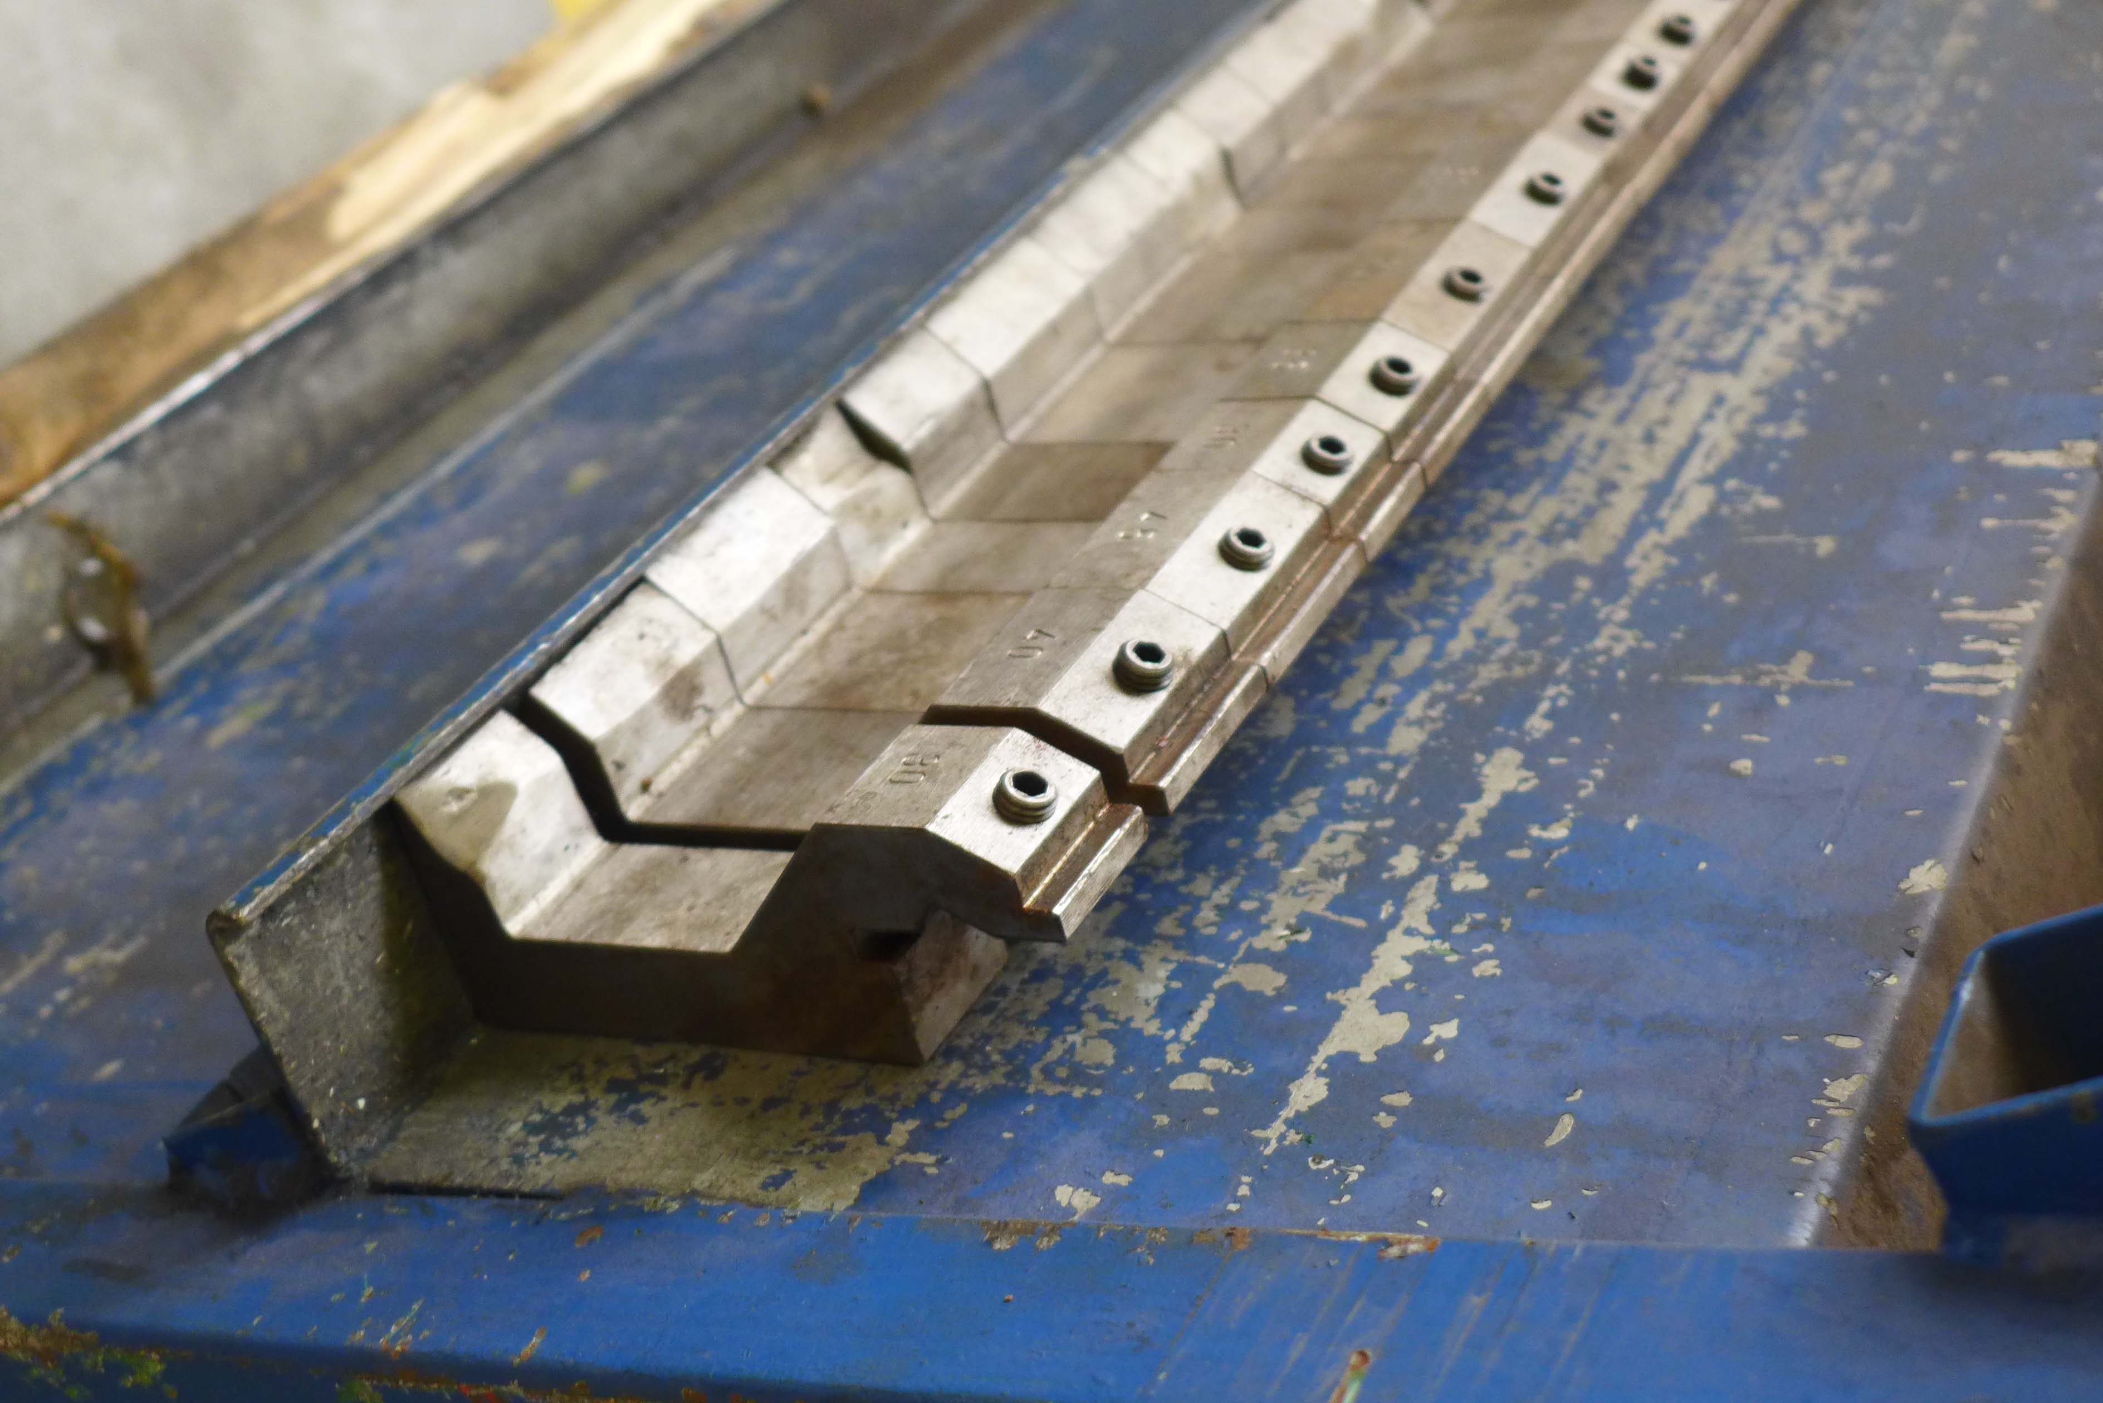
- Positioning speed 200 mm/Sec

- 1 set tooling Sharp 45 Gr
- 1 set tooling L 88 Gr.

- Dimensions
- Length : 3.900
- Depth : 2.750
- Height : 2.530
- Weight : 5.400 Kg

Please Note: The above information has been obtained to the best of our ability and belief from, and from the manufacturers where possible. It is given in good faith, but its accuracy can not be guaranteed. Accordingly, it will not form a representation or constitute contractual terms. We advise you to check any vital details!

